

GSM PUMP MOTOR CONTROLLER CIRCUIT USING ARDUINO

A REPORT OF PROJECT BASED LEARNING (SEMESTER II)
Submitted by
HARSHAL WALUNJ VIRAJ MORE MAYUR MOTE RUSHIKESH PALVE AHMED SIDDIQUI GANESH CHORMALE

FIRST YEAR ENGINEERING

Society for Computer Technology and Research’s

PUNE INSTITUTE OF COMPUTER TECHNOLOGY

DHANKAWADI, PUNE – 43

A.Y. 2019-20

- CERTIFICATE -

This is to certify that the work incorporated in the report entitled " GSM PUMP MOTOR CONTROLLER CIRCUIT USING ARDUINO ", is carried out by Mr. Mote Mayur Dnyandev (Roll No. 10514), who is part of a group of students with Project Id 3A52020 under the subject Project Based Learning during A.Y. 2019-2020.
Such material has not been submitted to any other university/ institute for any financial support. The literature related to the problem investigated has been appropriately cited and duly acknowledged wherever facilities and suggestions have been availed of.

Date: Name and Sign of Project Guide
Place: PUNE

Prof. S. D. Hade

Name & Sign of PBL Coordinator Name & Sign of Head of Department

Prof. N. P. Sapkal Prof. E. M. Reddy

ABSTRACT
As we all know that India is an agriculture-oriented country, now a day’s our farmers are facing very difficulties in irrigating the land due to the lack of power supply or unable to get the required supply on-time. Required power supply to run the irrigation motor (3Phase) will get usually in night in villages, very hardly they get power in day time. So, to turn on the motor someone has to go to the field and turn on. Keeping this in mind we came up with the concept called “Remote Water Pump Controller for Agriculture Using GSM”. This can be used to turn ON and OFF the Motor Remotely.

ACKNOWLEDGEMENT
We would like to express our special thanks of gratitude to our prof. S.D. Hade as well as our principal sir who gave us the golden opportunity to do this wonderful project on the topic of Remote irrigation. This helped us in doing a lot of Research and we came to know about so many new things. We are really thankful to them as we were given enough guidance and time to complete our project. The teachers were very helpful at every stage. Information and methods regarding the project were given to us by the teachers. The teachers gave us a lot of freedom on how to make the projects. Our various ideas were accepted and tested by the teachers and the students. The project is a combined effort of all the group members. It was possible due to the hard work and the efforts everyone put in.

Place: Name of Student (in Capital) & Sign

TABLE OF CONTENT

Chapter No. | Title | Page No.
1 | Introduction | 1
2 | Requirements | 2
3 | Experimental setup | 11
4 | Working | 14
5 | Result and analysis | 17
6 | Future Scope | 18
7 | Conclusion | 19
8 | References | 21

LIST OF TABLES

Table No | Title | Page No
2.1 | Pins | 4
5.1 | Observation table | 17

LIST OF FIGURES

Figure No | Title | Page No
2.1.1 | Arduino Uno | 3
2.1.2 | GSM Module | 5
2.2.1 | LED’s | 7
2.2.2 | Jumper wire’s | 8
2.2.3 | Resistor | 8
2.2.4 | SIM Card | 9
2.2.5 | Relay | 9
2.2.6 | AC to DC adapter | 10
3.1 | Experimental setup | 11
3.2 | Block Diagram representation | 12
3.3 | Pin Diagram | 13

Nomenclature

V | Voltage
A | Ampere
Ω | Ohm

Chapter 1
INTRODUCTION
Agriculture is one of biggest industries in India which serves food for more than a billion people every year. Producing vast amounts of food is never an easy task; irrigation is one of the factors. Most of the agriculturist’s crop fields are situated far from their residence, just turning on the water pump costs huge for their transportation per year. Electric irrigation pumps are used from many years for this purpose. But farmers are facing lots of problems while operating the irrigation pumps. The major problems faced by the farmers are-
- Physical effort and inconvenience
- Frequent damage of irrigation equipment
- Frequent damage of irrigation equipment
In present scenario, irrigation techniques in India are through the manual control in which the farmers irrigate the land at regular intervals. Manual operation of the routine practices in agriculture requires lot of attention and care. Also it is difficult to perform desired jobs efficiently and precisely. Ultimately this may result in lower crop production, nonuniform growth and poor quality. The introduction of automation in irrigation system will result in increased application efficiency and drastically reduce labor requirement. The proposed system helps to monitor and control the irrigation system using a simple mobile phone. The automation includes distant control of motor operation using GSM. We are going to construct a farmer Friendly GSM pump motor controller circuit which could turn on and off the irrigation system remotely from anywhere in the world via cellphone SMS and return you with an acknowledgement message, Using minimum hardware components. We are working under telecommunications as well as IT domains. We are planning to learn the functioning and working of Arduino, relay and GSM module.

Chapter 2
REQUIREMENTS
Main requirements of the project are:
- GSM module
- Arduino UNO
Other Requirements of the project are:
- LED’s
- Jumper wires
- Relay switch
- Resistors (330 ohm)
- SIM card
- 12v 1A Adapter for GSM module
- Relay Switch 5V

Arduino Uno: -
The UNO is the best board to get started with electronics and coding. If this is your first experience tinkering with the platform, the UNO is the most robust board you can start playing with. The UNO is the most used and documented board of the whole Arduino & Genuino family. Arduino/Genuino Uno is a microcontroller board based on the ATmega328P (datasheet). It has 14 digital input/output pins (of which 6 can be used as PWM outputs), 6 analog inputs, a 16 MHz quartz crystal, a USB connection, a power jack, an ICSP header and a reset button. It contains everything needed to support the microcontroller; simply connect it to a computer with a USB cable or power it with an AC-to-DC adapter or battery to get started. The Arduino Uno is an open-source microcontroller board developed by Arduino.cc. And is programmable with the Arduino IDE (Integrated Development Environment), via a type B USB cable. It can be powered by the USB cable or by an external 9-volt battery, though it accepts voltages between 7 and 20 volts.

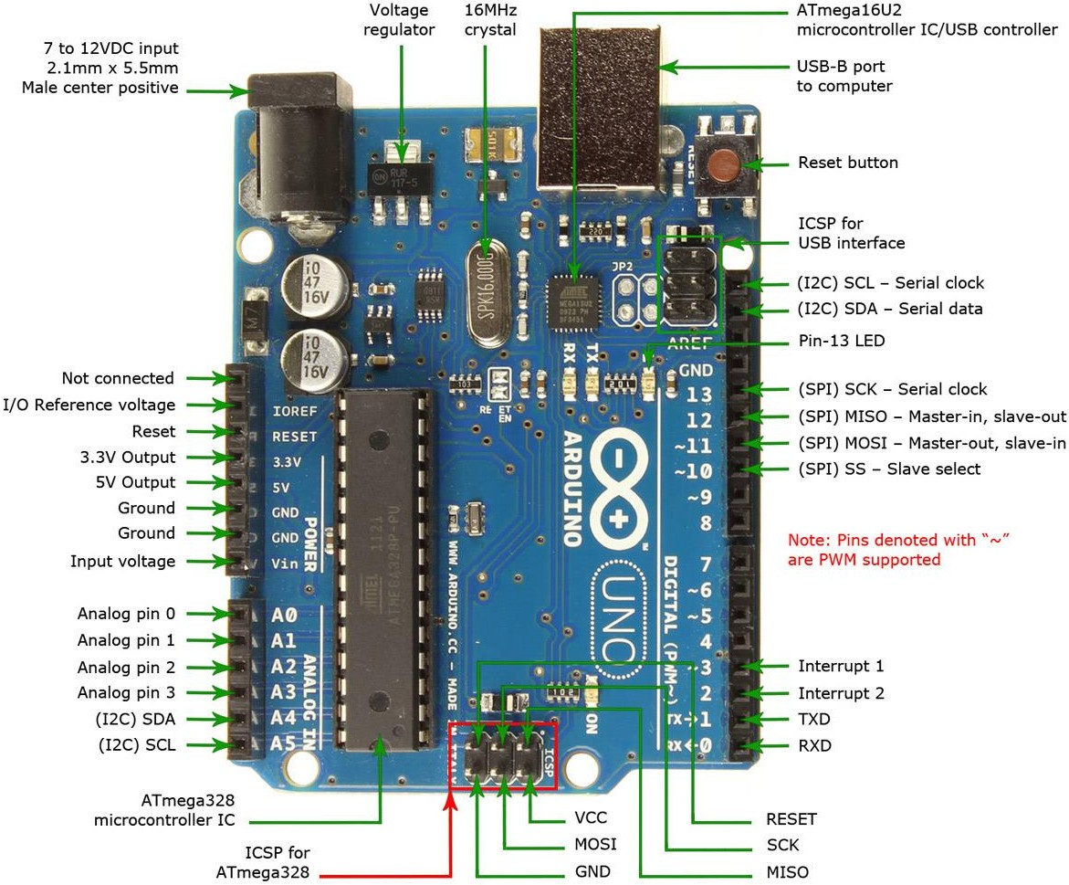
Fig-2.1.1-Arduino UNO

Technical specification-
      - Microcontroller: Microchip ATmega328P [7]
      - Operating Voltage: 5 Volts
      - Input Voltage: 7 to 20 Volts
      - Digital I/O Pins: 14 (of which 6 can provide PWM output)
      - UART: 1
      - I2C: 1
      - SPPI: 1
      - Analog Input Pins: 6
      - DC Current per I/O Pin: 20 mA
      - DC Current for 3.3V Pin: 50 mA
      - Flash Memory: 32 KB of which 0.5 KB used by bootloader
      - SRAM: 2 KB
      - EEPROM: 1 KB
      - Clock Speed: 16 MHz
      - Length: 68.6 mm
      - Width: 53.4 mm
      - Weight: 25 g
Sr.no | Pin | Function
1. | LED | There is a built-in LED driven by digital pin 13. When the pin is high value, the LED is on, when the pin is low, it is off.
2. | VIN | The input voltage to the Arduino/Genuino board when it is using an external power source (as opposed to 5 volts from the USB connection or other regulated power source). You can supply voltage through this pin, or, if supplying voltage via the  power jack, access it through this pin.
3. | 5V | This pin outputs a regulated 5V from the regulator on the board. The board can be supplied with power either from the DC power jack (7 - 20V), the USB connector (5V), or the VIN pin of the board (7-20V). Supplying voltage via the 5V or 3.3V pins bypasses the regulator, and can damage the board.
4. | 3.3V | A 3.3-volt supply generated by the on-board regulator.  Maximum current draw is 50 mA.
5. | GND | Ground pins.
6. | RESET | Typically used to add a reset button to shields that block the one on the board.
7. | IOREF | This pin on the Arduino/Genuino board provides the voltage reference with which the microcontroller operates. A properly configured shield can read the IOREF pin voltage and select the appropriate power source, or enable voltage translators on  the outputs to work with the 5V or 3.3V.
Table no.2.1 Pins

GSM Module: -
A GSM module or a GPRS module is a chip or circuit that will be used to establish communication between a mobile device or a computing machine and a GSM or GPRS system. The modem (modulator-demodulator) is a critical part here.
These modules consist of a GSM module or GPRS modem powered by a power supply circuit and communication interfaces (like RS-232, USB 2.0, and others) for computer. A GSM modem can be a dedicated modem device with a serial, USB or Bluetooth connection, or it can be a mobile phone that provides GSM modem capabilities. SIM800 is a quad-band GSM/GPRS module that works on frequencies 850MHz GSM, 900MHz EGSM, 1800MHz DCS, and 1900MHz PCS.It also features GPRS multi-slot class 12/class 10 (optional), and supports CS-1, CS-2, CS-3, and CS- 4 GPRS coding schemes.
It has one UART port. It also has one USB port that can be used for updating firmware and for debugging. Audio channels are also there, which include a microphone input and a receiver output. SIM800 has one SIM card interface. It integrates TCP/IP protocol. SIM800 can be controlled/configured using simple AT commands. A host microcontroller can send AT commands over the UART interface and control the SIM800.SIM800 operates on a supply in the range of 3.4 to 4.4V. It can be used for sending/receiving messages, making calls, sending/receiving data over the internet, etc. This makes it useful for applications such as home automation, agriculture automation, etc.
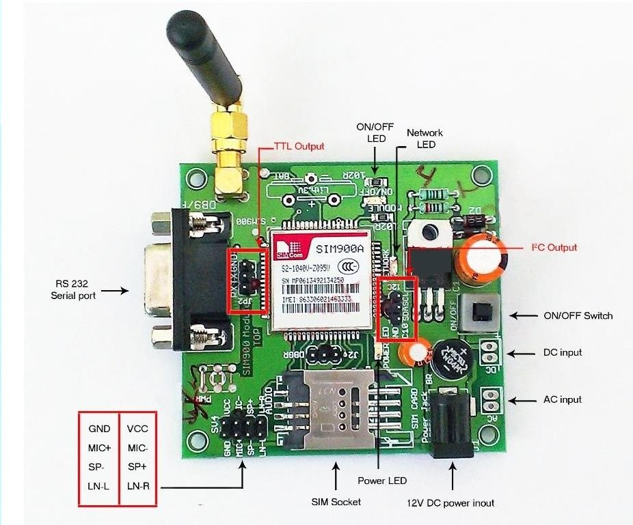
Fig-2.1.2-GSM module

General features
- Quad-band 850/900/1800/1900MHz
- GPRS multi-slot class 12/10
- GPRS mobile station class B
- Compliant to GSM phase 2/2+
– Class 4 (2 W @ 850/900MHz)
– Class 1 (1 W @ 1800/1900MHz)
- Bluetooth: compliant with 3.0+EDR
- Dimensions: 24*24*3mm
- Weight: 3.14g
- Control via AT commands (3GPP TS 27.007,
- 27.005 and SIMCOM enhanced AT Commands)
- Supply voltage range 3.4 ~ 4.4V
- Low power consumption
- Operation temperature: -40℃ ~85℃
Specifications for SMS via GSM/GPRS
- Point to point MO and MT
- SMS cell broadcast
- Text and PDU mode
Compatibility
- AT cellular command interface
Software features
- 0710 MUX protocol
- Embedded TCP/UDP protocol
- FTP/HTTP
- MMS
- E-MAIL
- DTMF
- Jamming Detection
- Audio Record

LED’s: -
In the simplest terms, a light-emitting diode (LED) is a semiconductor device that emits light when an electric current is passed through it. Light is produced when the particles that carry the current (known as electrons and holes) combine together within the semiconductor material.
Since light is generated within the solid semiconductor material, LEDs are described as solid-state devices. The term solid-state lighting, which also encompasses organic LEDs (OLEDs), distinguishes this lighting technology from other sources that use heated filaments (incandescent and tungsten halogen lamps) or gas discharge (fluorescent lamps).

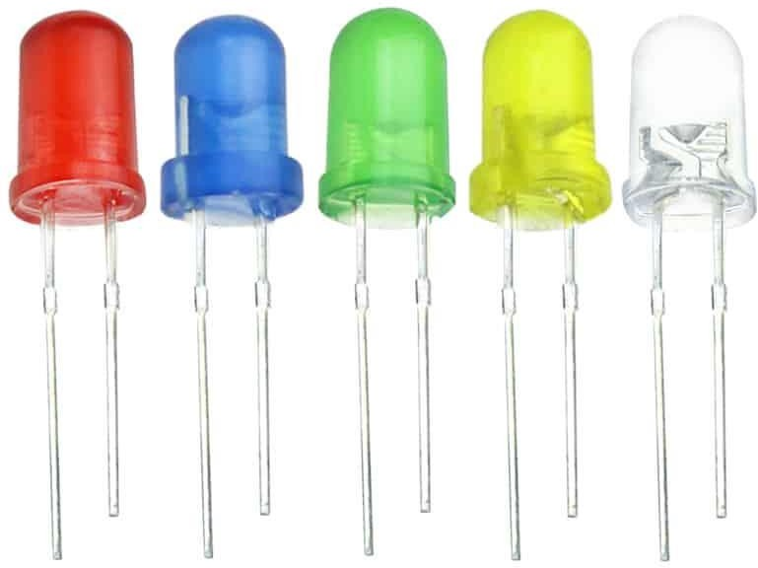

Fig 2.2.1 LED

Jumper Wires: -
A jump wire (also known as jumper wire, or jumper) is an electrical wire, or group of them in a cable, with a connector or pin at each end (or sometimes without them – simply "tinned"), which is normally used to interconnect the components of a breadboard or other prototype or test circuit, internally or with other equipment or components, without soldering.
Individual jump wires are fitted by inserting their "end connectors" into the slots provided in a breadboard, the header connector of a circuit board, or a piece of test equipment.
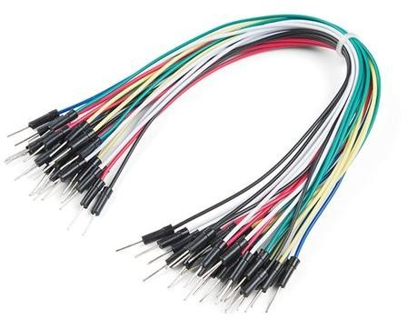

Resistor (330 Ω): -
Fig 2.2.2 Jumper Wires

330 ohms may be used by some people as a "get you going" value that works "well enough" in many cases. The purpose of the resistor is to "drop" voltage that is not required to operate the LED, when the LED is operating at the desired current.

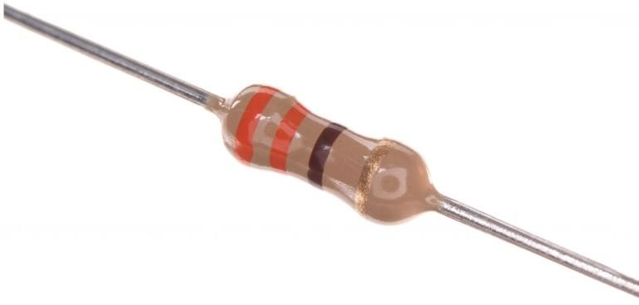

Fig 2.2.3 Resistor (330 Ω)

    - SIM card: -
A subscriber identity module or subscriber identification module (SIM), widely known as a SIM card, is an integrated circuit that is intended to securely store the international mobile subscriber identity (IMSI) number and its related key, which are used to identify and authenticate subscribers on mobile telephony devices (such as mobile phones and computers). It is also possible to store contact information on many SIM cards. SIM cards are always used on GSM phones; for CDMA phones, they are only needed for newer LTE-capable handsets. SIM cards can also be used in satellite phones, smart watches, computers, or cameras.
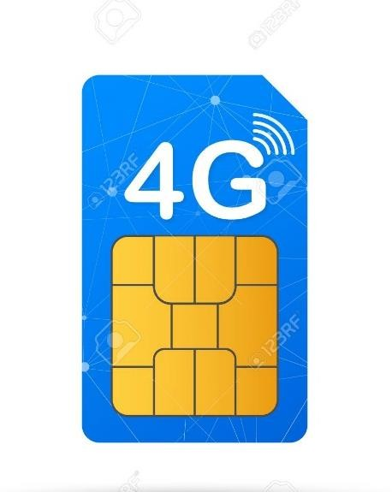

Relay 5V: -
Fig 2.2.4 SIM Card

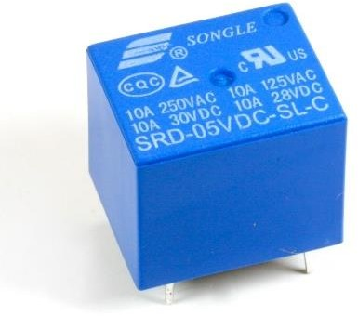
Channel 5V Relay Module is a relay interface board, it can be controlled directly by a wide range of microcontrollers such as Arduino, AVR, PIC, ARM and so on. It uses a low-level triggered control signal (3.3-5VDC) to control the relay. Triggering the relay operates the normally open or normally closed contacts. It is frequently used in an automatic control circuit. To put it simply, it is an automatic switch to control a high-current circuit with a low-current signal.5V relay signal input voltage range, 0- 5V. VCC power to the system. JD-VCC relay in the power supply. JD-VCC and VCC can be a shorted.
Fig 2.2.5 Relay Switch

AC to DC Adapter (12V 1A): -
The 12 Volt Adapter Power Supply is probably the most widely used power adapter. The 12 Volt Power Supply Adapter is a throwback to the early days of electronics when 12V was a common battery output voltage. With the move by the consumer to use solid state equipment in the car and then into home was inevitable as one basic design was universal. The 12 Volt Power Adapter, also known as a "Brick", "Desk Wart" and "Floor" supply, provide a regulated 12 Volts DC output. A 12 Volt Adapter Power Supply is enclosed in a plastic protective case that comes with either an attached AC cord, or a mating socket for one of the 3 common IEC cordsets.
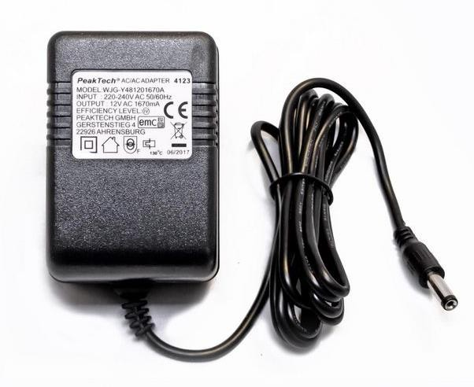

Fig 2.2.6

Chapter 3
EXPERIMENTAL SETUP

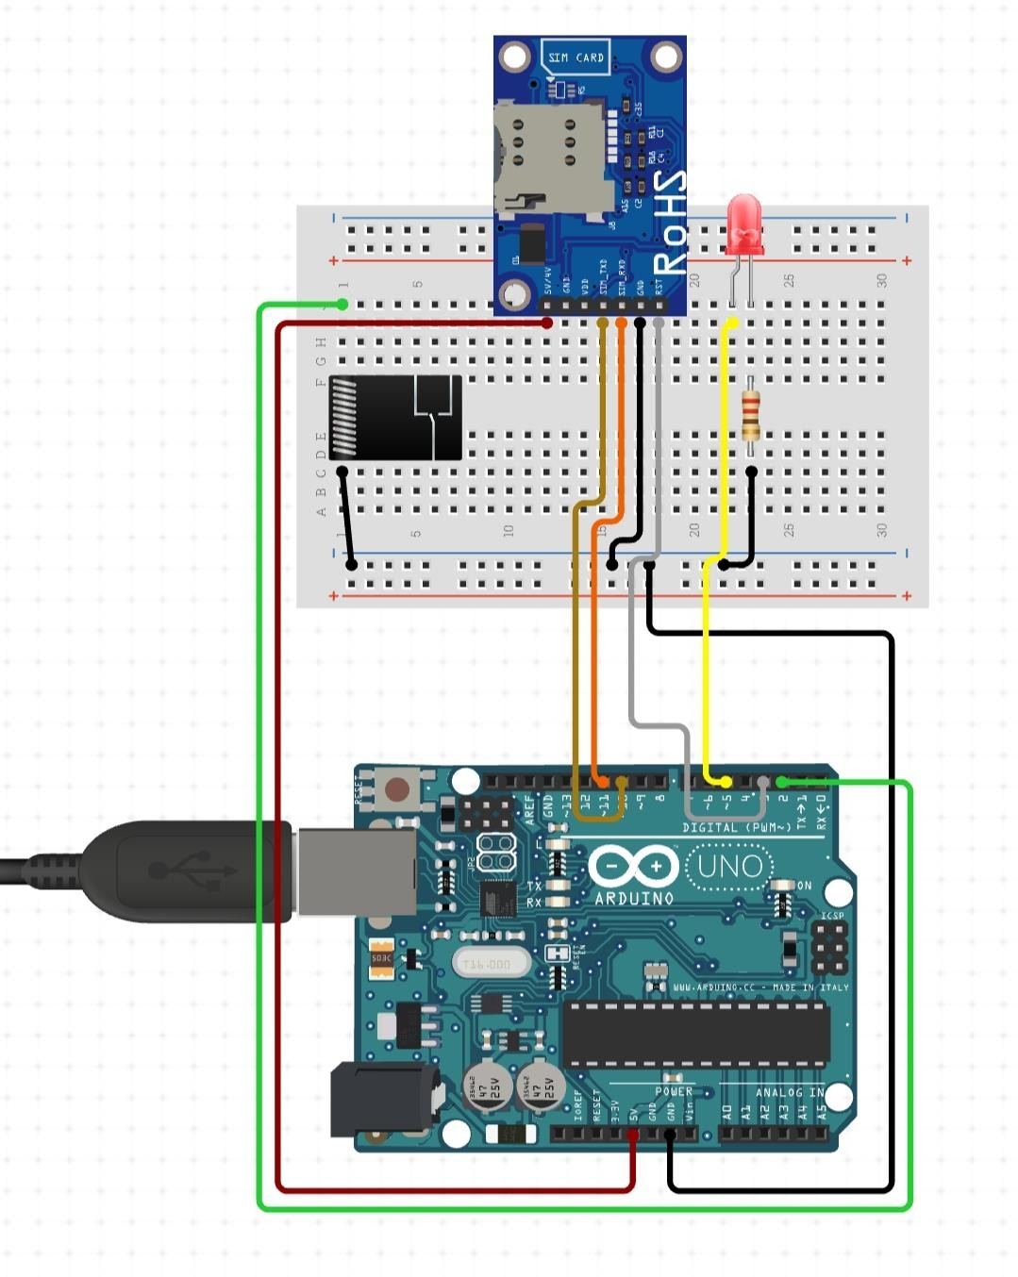
Fig 3.1 Experimental Setup

3.1 Connecting GSM Module to Arduino
There are two ways of connecting GSM module to Arduino. In any case, the communication between Arduino and GSM module is serial. We are supposed to use serial pins of Arduino (Rx and Tx). Connect the Tx pin of GSM module to Rx pin of Arduino and Rx pin of GSM module to Tx pin of Arduino. GSM Tx –> Arduino Rx and GSM Rx –> Arduino Tx. Now connect the ground pin of Arduino to ground pin of gsm module. Now you can load different programs to communicate with gsm module and make it work.

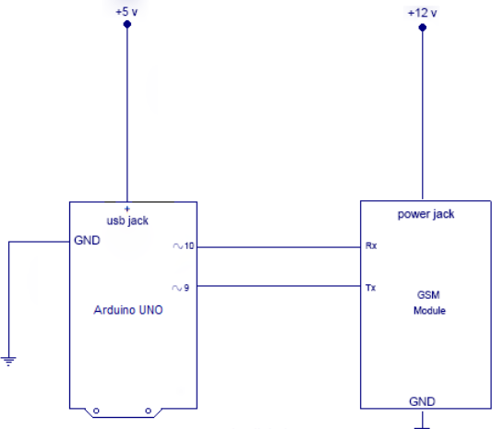
Fig No 3.2: BLOCK DIAGRAM REPRESENTATION

In the connection between the Arduino Uno and the GSM module, the GSM module (SIM 900A) may not require the explicit power supply, rather it can be powered using the 5V voltage pin of the Arduino Uno used in the setup. This will enhance the portability and flexibility of the system to the further extent

Relay Connections
Connect the 3V voltage pin and GND pin of Arduino Uno to the coil pins of the SPDT relay respectively. Also connect the COM pin of the SPDT relay to the GND pin of Arduino Uno. The polarity doesn’t matter in the connection between the COIL pins and the Arduino Uno pins, as one side gets positive voltage and the other side gets negative voltage. But if any diode is directly connected to the relay in the setup, then special care of the relay’s polarity is to be taken.

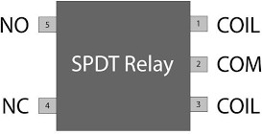

Fig 3.3: PIN DIAGRAM

Now, connect the NO pin of the SPDT relay to the anode of the led which will indicate the status of the motor i.e. ON or OFF. If the led is glowing, this indicates the motor is currently working.
Further connect the cathode of the led to the GND pin of the Arduino Uno and also make sure that a resistor (330Ω to 1kΩ) is also connected between the led and the Arduino Uno pin.

Chapter 4
WORKING
A fixed 12V voltage regulator gives power to Arduino, GSM modem and relay. The GSM modem is connected to Arduino at pin #0 and pin #1, which are RX and TX respectively.
The RX of GSM is connected to TX of Arduino and TX of GSM is connected to RX of Arduino.
The LED indicator shows the status of the relay. If the LED glows the relay activated and if the LED is off, the relay is deactivated.

Program Code-
int LED = 8; int motor = 9; int temp=0; int i=0;
char str[15]; void setup()
{
Serial.begin(9600); pinMode(motor,OUTPUT); pinMode(LED,OUTPUT); digitalWrite(motor,LOW); digitalWrite(LED,LOW); delay(20000); delay(20000); delay(20000);
Serial.println("AT+CNMI=2,2,0,0,0"); delay(1000); Serial.println("AT+CMGF=1"); delay(500);
Serial.println("AT+CMGS=\"+918483074163\"\r"); delay(1000);
Serial.println("MOTOR ON."); delay(100); Serial.println((char)26); delay(1000);
}
void loop()
{
if(temp==1)
{
check(); temp=0; i=0;
delay(1000);
}
}

void serialEvent()
{
while(Serial.available())
{
if(Serial.find("/"))
{
delay(1000);
while (Serial.available())
{
char inChar=Serial.read(); str[i++]=inChar; if(inChar=='/')
{
temp=1; return;
}
}
}
}
}
void check()
{
if(!(strncmp(str,"motor on",8)))
{
digitalWrite(motor,HIGH); digitalWrite(LED,HIGH); delay(1000);
Serial.println("AT+CMGS=\"+918483074163\"\r"); delay(1000);
Serial.println("Motor Activated"); delay(100); Serial.println((char)26); delay(1000);
}
else if(!(strncmp(str,"MOTOR OFF",9)))
{
digitalWrite(motor,LOW); digitalWrite(LED,LOW); delay(1000);
Serial.println("AT+CMGS=\"+918483074163\"\r"); delay(1000);
Serial.println("Motor deactivated"); delay(100); Serial.println((char)26); delay(1000);
}

else if(!(strncmp(str,"test",4)))
{
Serial.println("AT+CMGS=\"+918483074163\"\r"); delay(1000);
Serial.println("The System is Working Fine."); delay(100);
Serial.println((char)26); delay(1000);
}
}

How to use the System?
    - Send /motor on/ SMS from your cellphone to activate the relay.

    - Send /motor off/ SMS to deactivate the relay.

    - Send /test/ SMS for testing the response from the circuit.

    - /motor on/ will turn ON the relay and return with an acknowledgement SMS “Motor Activated.”

    - /motor off/ will turn off the relay and return with an acknowledgement SMS “Motor Deactivated.”

    - If you send /test/ it will return with an acknowledgement SMS “The System is Working Fine.”

Chapter 5
RESULT AND ANALYSIS
Going through the planning, flow process, design and software implementation, the system has been a tough one, we have actually tried as much as possible to explain vividly almost all (if not all) what is involved in the construction of this project. After the complete design of the system, the deviation between the expected result and the actual result was very close. All the results are simulated using Arduino and GSM module. Also, all the states of circuits are checked using LED indicators. We got following results from implemented dummy system.

Observation Table:
Sr.no. | Observations | Status of motor | Message received by user
1. | User make call to turn on motor | ON | Motor started.
2. | User make call to turn off motor | OFF | Motor stopped.
3. | User messages “MOTOR ON” to turn on motor | ON | Motor started.
4. | User messages “MOTOR OFF” to  turn on motor | OFF | Motor stopped.
Table no.5.1 Observation table

A Person can remotely Control the water Flow in the Farm through SMS. So, whenever the person sends “turn on” message from his phone, the microcontroller on the other side will receive that SMS through GSM module and take appropriate decision to turn on the Water pump and same goes for turning off the pump.
By this way one can manage water efficiently during farming and also reduce the water and power consumption.
Our project has several advantages –
- User can operate pump/motor from anywhere, from any distance
- User can operate pump via SMS
- Low operating costs due to SMS function
- GSM Technology, Reliable operation, Worldwide Connectivity
- Low Cost, Quality and less maintenance and robust device
- ARDUINO UNO is too much reliable as data will be retained for 20 years

Chapter 6
FUTURE SCOPE
India is known for IT skills and it is already established that there lies great potential among Engineers and Scientists. But the skills are not uniformly distributed across different fields; agriculture is one of the fields where technological development is slow. The GSM pump motor controller is here to change that. Here’s how:
An estimated 450 million of the population of India depends on farming for their livelihood with over 20% of all Indian farmers living below the poverty line and this is partly due to inefficient farming practices including the lack of automation of systems by Agtech. The GSM pump motor controller will act as a gateway into automation of various agricultural systems for all farmers who were unable to incorporate automation and thus far due to the high price set on agricultural technology. Fortunately, the pump motor controller in question, due to its low price and novelty of being one of the first products of its kind, is expected to achieve adoption by numerous farmers instantly, if available on the market.
Far more people in India have access to a cell phone than to a toilet and improved sanitation, according to UN experts and the GSM pump motor controller is planning of taking advantage of this situation. It is projected to be very popular amongst farmers solely due to its main selling factor, that is its ease of use and economical nature with a bang-for-buck pricing strategy. The pump motor controller is also expected to be highly subsidized by the Government of India as most new agricultural technology is. Being comprised of electronic components, it is also almost certain that the price for parts and hence production of the controller will decrease with time. This will incredibly increase product outreach and will achieve widespread adoption.
The controller also hopes to act as an inspiration to other individuals, groups, NGOs, companies and even corporations to dive into similar ventures to ultimately work towards the farmer’s welfare.
Even though the designed GSM pump motor controller is designed for farmers, it is created using an Arduino module which is amazing due to its versatility and the leeway it provides. Arduinos can behave as an opportunity towards creating numerous other projects cheaply and efficiently incorporating its ease of use. Arduinos can also act towards achieving a first step towards IOT and more internet integrated society. This is not only very important to the farming industry where 20% of all farmers are below the poverty line but also important to the individuals interested in studying the module and implementing it in their projects.

Chapter 7
CONCLUSION
Ongoing conventional motor control method of manual operation can be replaced by this new project water pump and water level control using GSM & mobile. So as to provide reliable simpler and easy way to control the pump. The use of GSM & mobile makes the control system simpler and to operate at any distance ranging from meters to kilometers. If the water tank at the irrigation site or may be in home, gets filled up, and if person is not there at the site, then there will be pole of water as well as continuous running of motor and wastage of power will be there. So, person has to go on site to operate the motor. Hence till that time there will be wastage of time, power as well as poling of water. This result in burden for both consumer and the electricity supply company as there will wastage of power. And the consumer has to pay more electric bill. And also, if he uses infrared remote- control system then also, he has to go onsite to operate the motor. Because the infrared remote-control system cannot operate for long distance. Water pump control and water level sensing using GSM and mobile will provide easier and simpler control of water pump. With this new control system, we can control the motor from long distance ranging from meters to kilometers. This system will save the power, time consumption as well as human power. This system is reliable and helpful for illiterates; they can also operate this new system. And this can also be operated in Domestic & Commercial fields. Especially this system is very helpful in irrigation applications.
This Automatic irrigation system is very useful and convenient, especially for those who travel at long distance. If installed and programmed properly, automatic irrigation systems can even save users money and helps to save the time required to detect and correct the faults in irrigation pumps. This enables users to take advantage of the globally deployed GSM networks with its low SMS service cost to use mobile phones and simple SMS commands to manage their irrigation system. This system is useful for farmers who have plenty of farm area so they need automation, for farmers who travels more and can’t give proper attention to their farms and mainly finds the applications in farms and housing areas to water plants.

Thus, the developed system enhances the water distribution in the field optimally. The system ensures protection of motor against overloads, overheating and phase imbalances. It also provides automated restarting if normal conditions are re-established. Uniform distribution of water at regular intervals, reduction in labor cost, prevention of unwanted water spillage, minimization of occurrences of motor faults and intimation to user about the completion of task are the major advantage of this system. The use of mobile phone has become more common among the farmers and hence used the system proves to be great boon to farmers whose pump sets are located far away from their homes due to capability of remote-control using cell phone and intimation about any abnormal conditions. The system is designed to have cell phone with in-built security against unauthorized users. Any cell phone model can be used for communication so that the system improves its adaptability to use. Low operating cost using messages and missed calls are the major attractions of this system.

REFERENCE
- S. Barrett, Embedded System Design with the Atmel AVR Microcontroller: PartI:Morgan Claypool,2009 [Online]
Available:http://ieeexplore.ieee.org/xpl/articleDetails.jsp?arnumber=6814202
- S. Barrett, Embedded System Design with the Atmel AVR Microcontroller: Part II Morgan Claypool,2009 [Online]
Available:http://ieeexplore.ieee.org/xpl/articleDetails.jsp?arnumber=6814198
- Nguyen Tang Kha Duy and Nguyen Dinh Tu and Tra Hoang Son and Luong Hong Duy Khanh,”Automated monitoring and control system for shrimp farms based on embedded system and wireless sensor network”,Electrical, Computer and Communication Technologies (ICECCT), 2015 IEEE International Conference
,March 2015
- https://agfundernews.com/how-to-encourage-the-adoption-of-agtech-innovation-in- india.html
- https://www.wikipedia.org/

